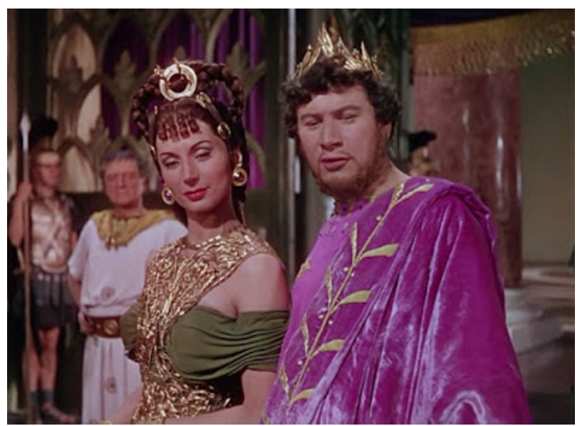
CLST 18/HIST 94.06
Fall 2020 VIRTUAL
Professor Stewart, Roberta.Stewart@Dartmouth.edu

Sect. 1: “C” hour (1020-1125 EST, xhour Th 1230-120)
Sect. 2: Arranged.

This course surveys the history of the Roman Empire from the civil wars of 43 BCE that spelled the end of the Roman Republic through the rule of Septimius Severus, the Roman emperor from the province of Africa.

The history of the Roman Empire is a history of the center, the central government and its constituencies. The principate (the rule of the “first citizen” or “princeps”) emerged as a political solution to civil war, and we spend the first few weeks of term watching the development of institutional controls on the arbitrary power of the princeps and the public ceremonies that regulated the coercive authority of the state. We also track the diversification of the ruling elite, first Roman, then Italian, then Spanish, then Gallic, then finally African and Near Eastern. We consider the mechanisms that made that diversification possible and the tensions in that system, the ideological exclusion of women and the reliance on enslaved labor.

But the real history of the Roman Empire is written in the many localities of the Roman world and the lived experience of all of the various peoples. We analyze its militarism, both conquest (Britain) and rebellion (Varus, Boudicca, Bar Kochba), and the system of frontiers, as defensive systems and as zones of cultural diversity. We track the cultural and social pluralism, the mobility of people at every level (elites, soldiers), the institutions creating coherence. Comparing Roman urban frameworks in North Africa, Britain, Athens, and Jerusalem illustrates its Roman sameness and local particularity.

Assignments. Weekly short writing assignments (to train on identifying basic historical categories, on tracking causation, on reading carefully a primary source), a midterm (or equivalent assignment), and final exam. A ZOOM game for enacting a process of government, with a write-up, will substitute for a paper.

